**Case 2 – Tableau Analytics (10 points)**

*For the following problems, you must utilize Tableau. You will utilize the data file “Case 2 – Tableau Data” to answer all the following questions (Note the data is clean, no underlying data needs to be changed). You will upload this completed Word document when finished:*

1. Foley Retail Co. is very profit driven. They have provided you with an excel file showing sales information for you to analyze. They have asked you to determine a product that they should eliminate that aligns with their profit driven strategy.
   1. Create a visualization in Tableau using the design rules we have discussed to find this solution. Paste a screenshot of the visualization you created:

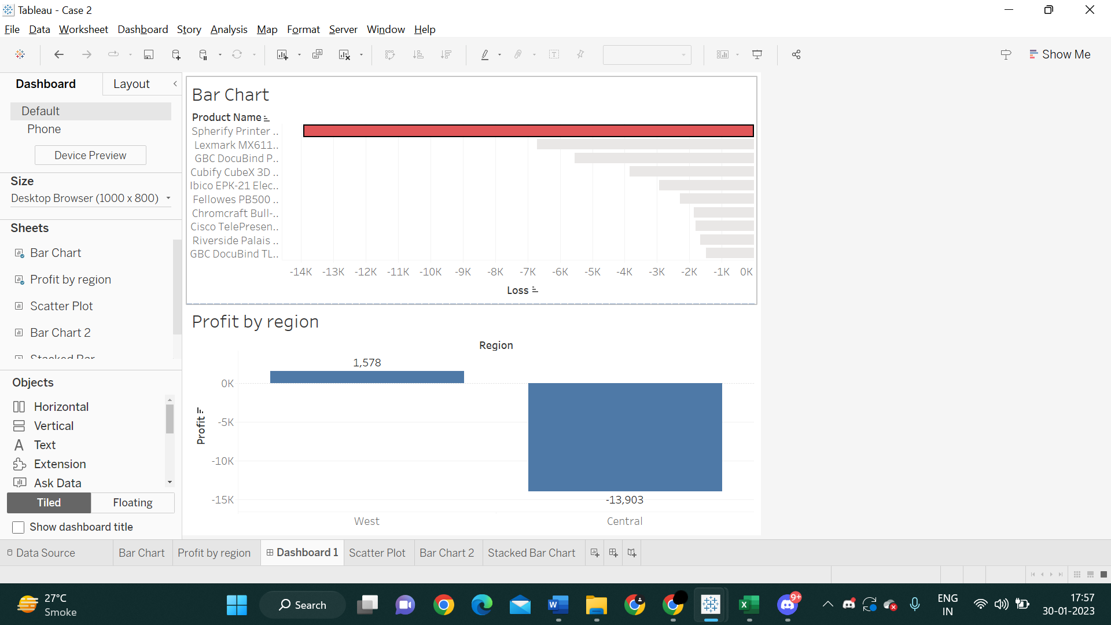

* 1. Which product should they discontinue (include the full name)?

**Answer :** Spherify Printer 3D Model BIHG

* 1. Would you eliminate this item from being sold in all regions? Why?

Spherify Printer has earned some amounts of profit in the West Region. So no, the product should not be eliminated from sales in all regions, just the Central region.

1. The company has asked you to analyze the relationship between Sales and Profit:
   1. Create a visualization (following our design rules) that allows you to determine what the R-squared relationship value is between Sales (Independent Variable) and Profit (dependent variable). Take a screenshot of the visualization and post it below:

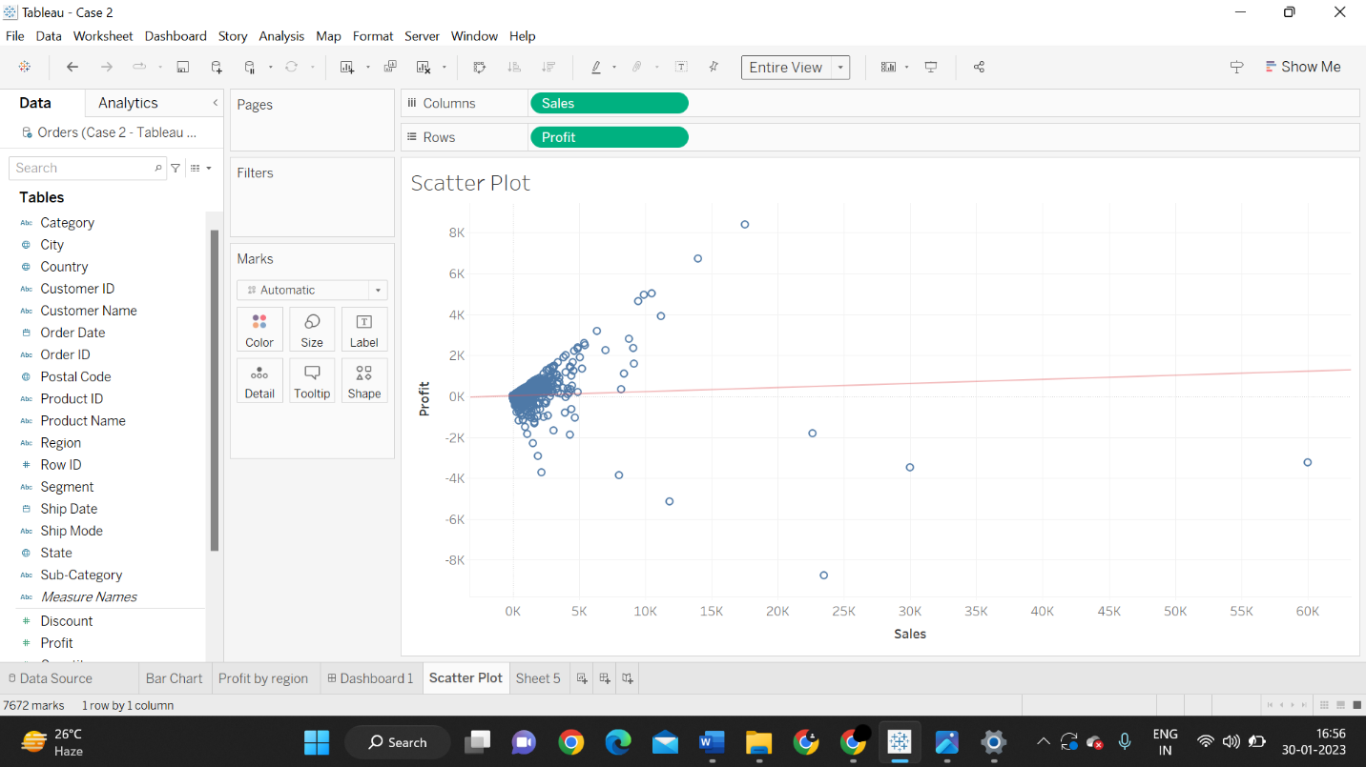

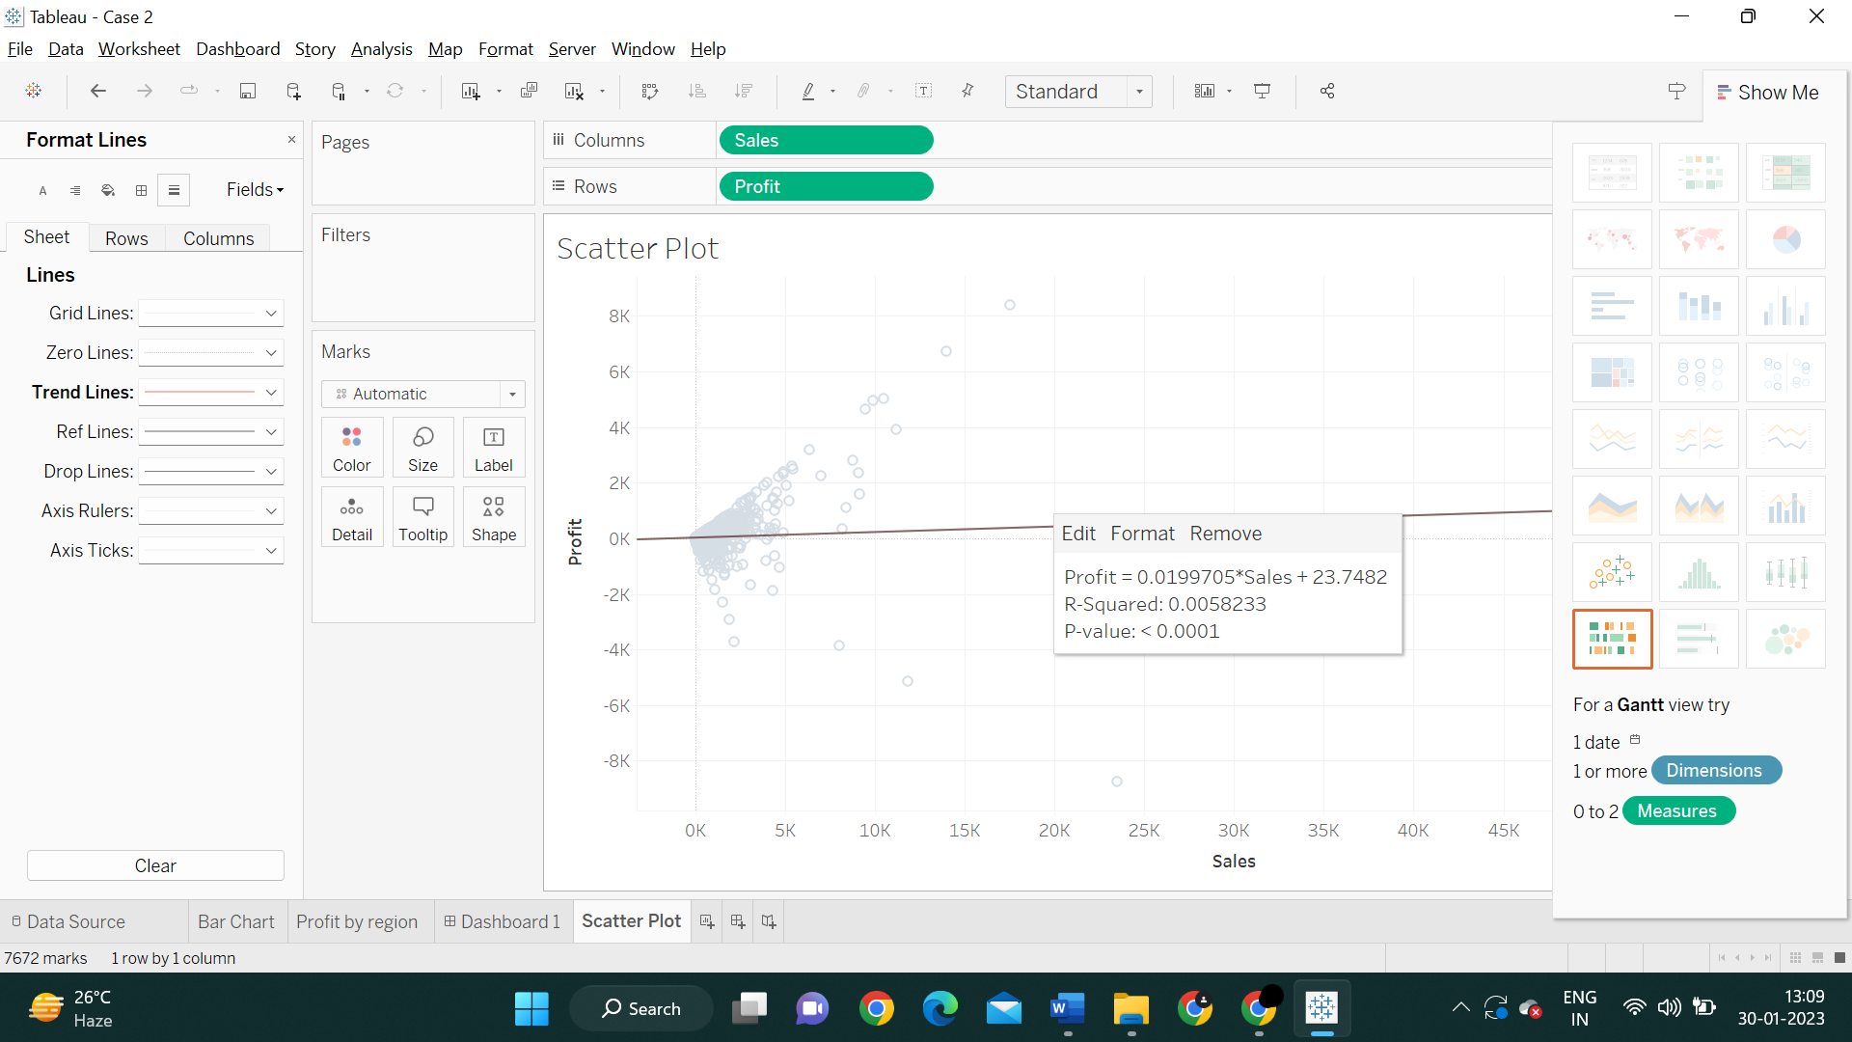

* 1. What is the R-squared value?

**Answer: 0.0058233**

1. For the state of Alabama:
   1. Which “Sub-Category” is most profitable overall?

**Answer:** Machines

* 1. Which “Sub-Category” is the least profitable overall?

**Answer:** Fasteners

* 1. Create a Visualization to support your answer to questions 3a and 3b *(Note, the visualization must be both effective and follow the design rules we discussed in class.)*

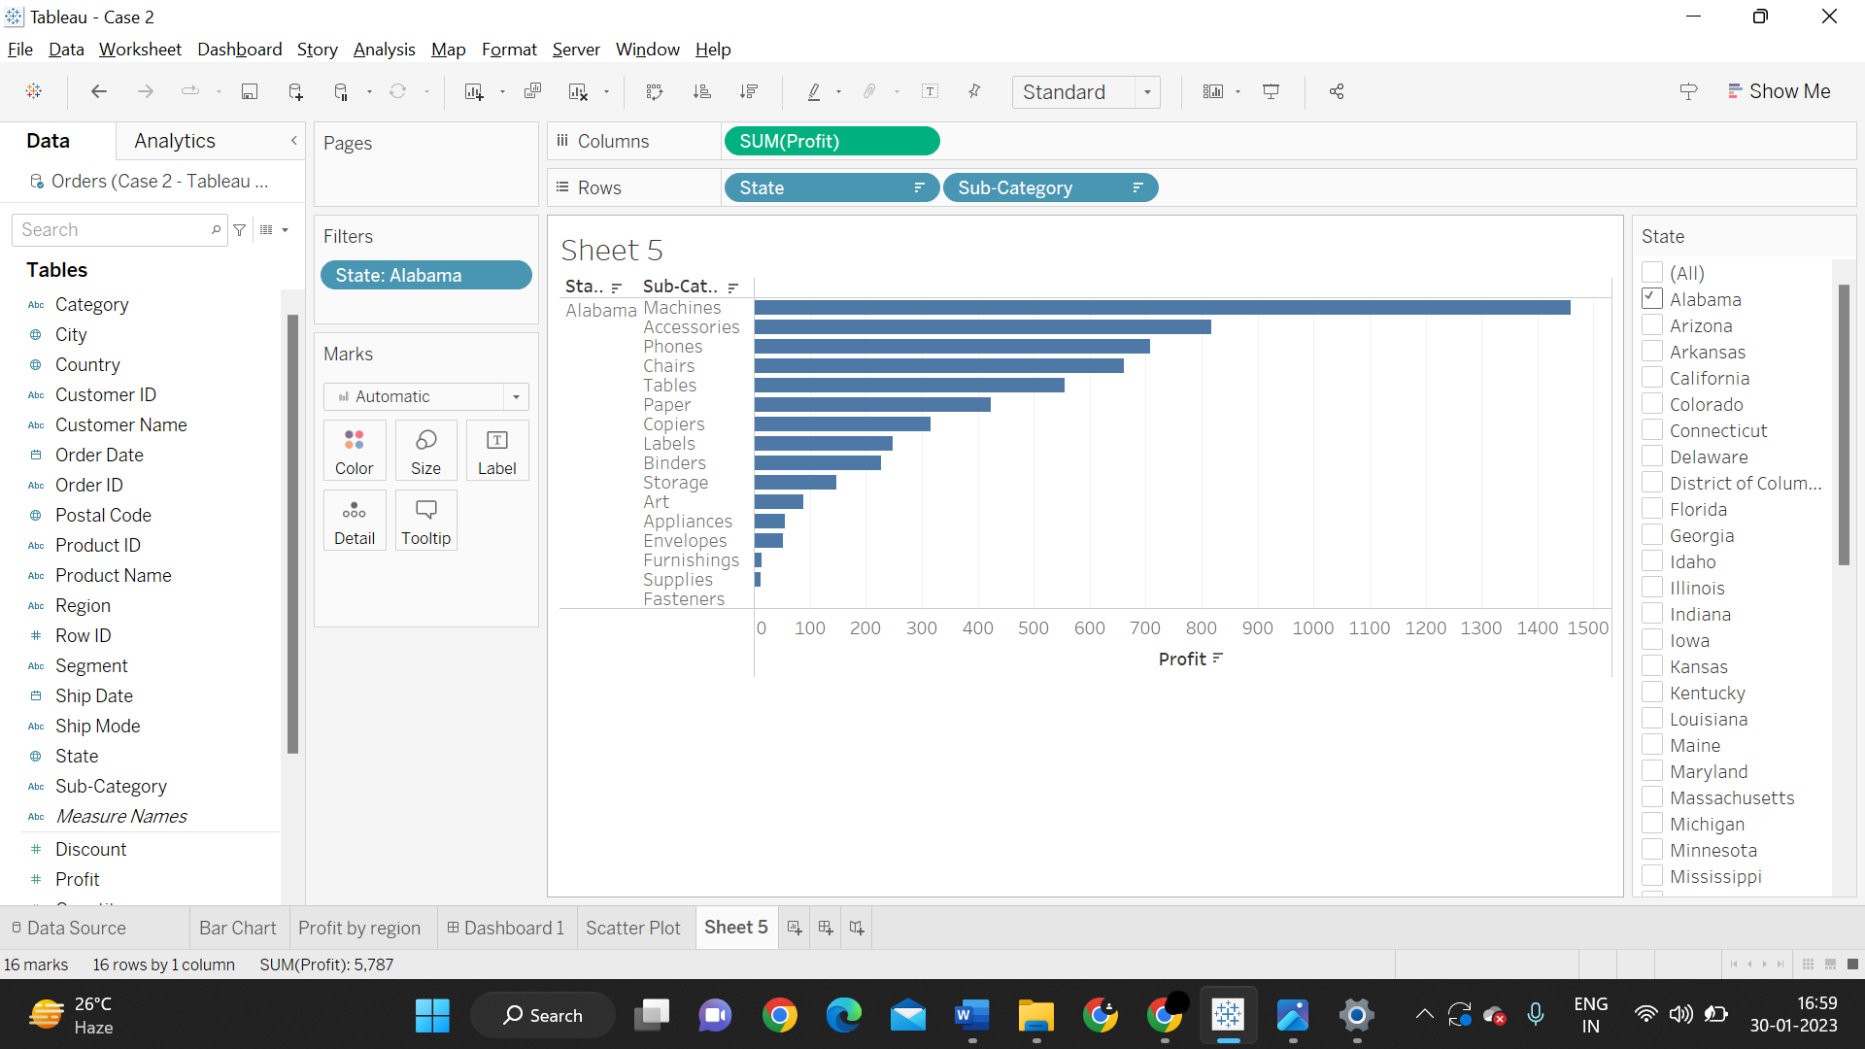

* 1. Create a stacked bar chart that shows the breakdown of Profit by Category by City for the state of Alabama *(This can be done in Tableau, Power BI or via a Pivot Chart and must be both effective and follow the design rules we discussed in class)*

